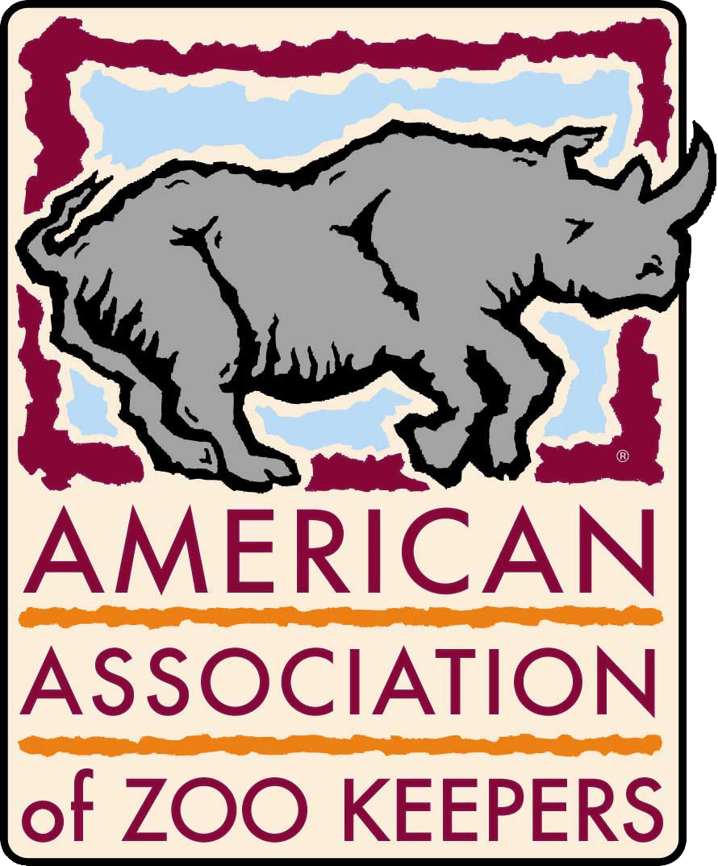
Trees for You and Me Grant
Submission Instructions and Requirements

- Grant application deadline is May 1 of each year. One completed application should be sent to the TFYM Grant Coordinator and one to the AAZK Administrative office. Applications also should be submitted digitally to the Grant Coordinator. If this is not possible 2 additional hard copies should be mailed to the Grant Coordinator. Late or incomplete applications will not be considered for review.
- The Grants Committee will score all complete applications. The grant finalist(s) will be notified by 15 December.
- The granting period runs from 1 January to 31 December of the year following application. This is the period of time in which the project is carried out with TFYM grant funding.
- Total available is the amount raised from TFYM the year of application.
- The Grants Committee reserves the right to split the funds among applicants if applicable.

APPLICATION INSTRUCTIONS
The Grant Application Form and Proposed Budget Form may be acquired from the AAZK website or by contacting the TFYM Grant Coordinator. A complete application includes the following:
- Introduction: Provided enough background information on the project for the Grants Committee to evaluate the relevance of the project.
- Scope & full proposal: Describe the location of the project and be specific about how the reforestation area will mitigate climate change. Include all appropriate federal, state, and local authorization for the project. An in depth description of the project including objectives and methods should be included.
- Proposed Budget: Be as specific as possible on expenditures. Money is available any time upon submission of receipts on items stated in the original budget. If there are changes that need to be made in the original budget, those changes must first be approved by the Grants Committee, TFYM Program, the Chief Executive Officer of AAZK. These changes should be submitted to the TFYM Grant Coordinator.
- Relevant References/Letters of Support: Three (3) letters of support should be digitally sent to the TFYM Grants Coordinator. If they cannot be sent digitally then attach the letters to your original application that will be mailed to the TFYM Grants Coordinator and AAZK Administrative Office.
- Resume of Primary Grant Applicant: The primary grant applicant need not be an AAZK member or affiliated with AAZK to apply, however preference may be given to AAZK members. A current resume should be submitted digitally. If this is not possible it can be attached to the original application that will be mailed to the TFYM Grants Coordinator.

GRANT DETAILS: Upon being awarded the grant, the following rules and schedule must be adhered to:
- Your name is the account identifier whenever transactions with AAZK Administrative Offices are made.
- A Progress Report is due six months following notification of the grant award. Submit the original report digitally to the TFYM Grants Coordinator. If this is not possible mail a hard copy to the AAZK Administrative Office.
- A Project Summary is due one year following notification of the grant award. Submit the original report digitally to TFYM Grants Coordinator and the CEO/CFO. This report should include a final accounting of the AAZK funds spent and along with the receipts.
- An extension of one year may be obtained by filing a One-Year Extension Form. No additional funds will be granted on the original proposal.
- Funds are allocated on a reimbursement basis only and are subject to approval by the Chief Executive Officer of AAZK. Original receipts should be sent to the AAZK Administrative Offices with your name on each as an identifier along with an address to send the reimbursement to. A copy should be sent to the TFYM Grants Coordinator. Receipts will be reviewed within ten working days. Approved reimbursements will be allocated after the review process is complete.
- Project results need to be presented by:
  - Orally at the National AAZK Conference OR
  - Published in the Animal Keepers’ Forum
If funds in addition to the AAZK Grant were used to complete the conservation project, the participant may request that the paper presented at an AAZK conference not be published in the conference proceedings. However, acknowledgment of AAZK support shall be required in all publications resulting from this conservation effort.
- Any grant recipient may submit a second proposal following successful completion of the first project.
- Failure to comply with any of the above mentioned regulations may result in the revocation of the grant at any time.

Additional Details:
- If an applicant is not awarded any part of the Grant fund he/she will be permitted to apply for any of the grants available upon the next date of submission.
- If an applicant is awarded any or all of the Grant money he/she will be permitted to apply for any of the grants available upon the next date of submission with the exception of the Grant they were awarded. They must sit out a cycle before reapplying for the grant they were awarded funds.
- Applicants who do not receive any of the Grant fund will be notified within 30 days of the Board’s decision or 1 November, whichever is earlier.

All forms can be found and printed off the AAZK, Inc. website
www.aazk.org

All submissions should be sent to:
One copy to:
AAZK Administrative Offices
8476 E Speedway Blvd
Suite 204
Tucson, AZ 84710-1728

Signed copy to:
Dawn Fleuchaus
TFYM Grant Coordinator
Conservation@AAZK.org Attn: TFYM Grant

